***Networking Common Tasks***

Find the CLI command to list the network interfaces

The command to list the network interfaces is ipconfig on a windows machine.

It will display all network interfaces along with their IP addresses, subnet masks, and default gateways.

Result:

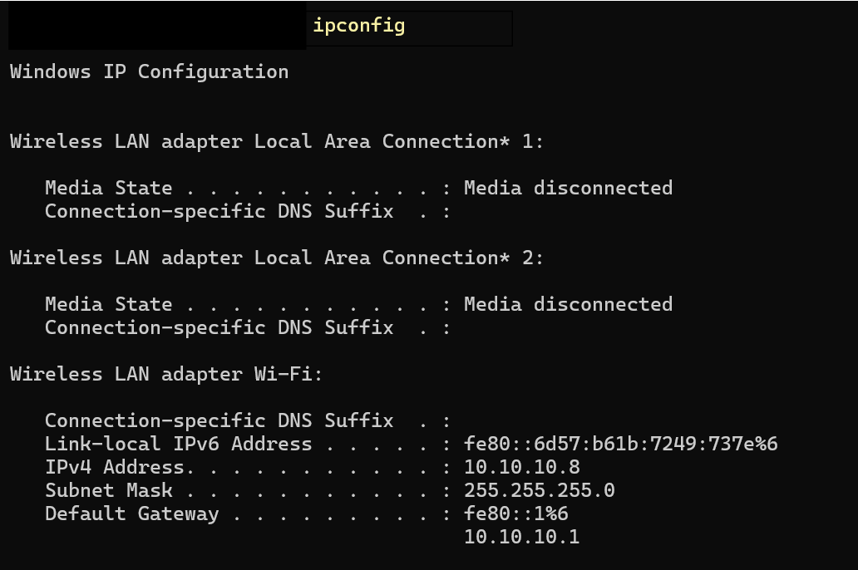

List all network interfaces on the system, including Ethernet interfaces, loopback interfaces, or any virtual interfaces.

Display Interface Configuration, i.e., details of each network interface, including IP address, subnet mask, broadcast address, and MAC address (hardware address).

Using ipconfig /all we can list all network interfaces, including Ethernet, loopback, and virtual interfaces.

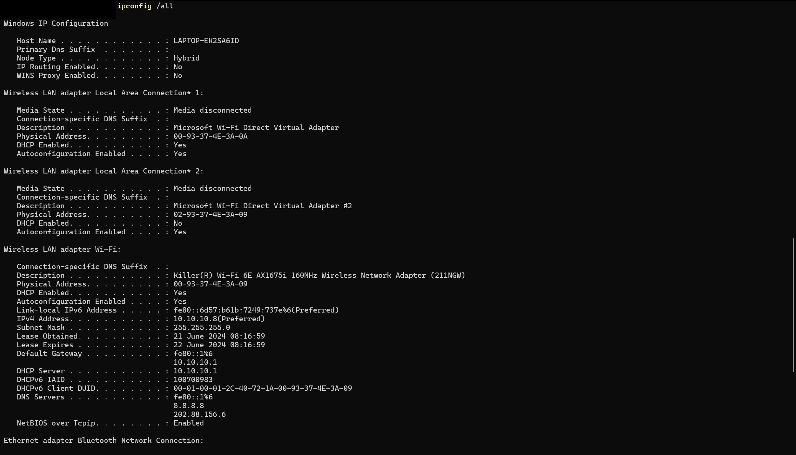

Assign static IP address using Netsh

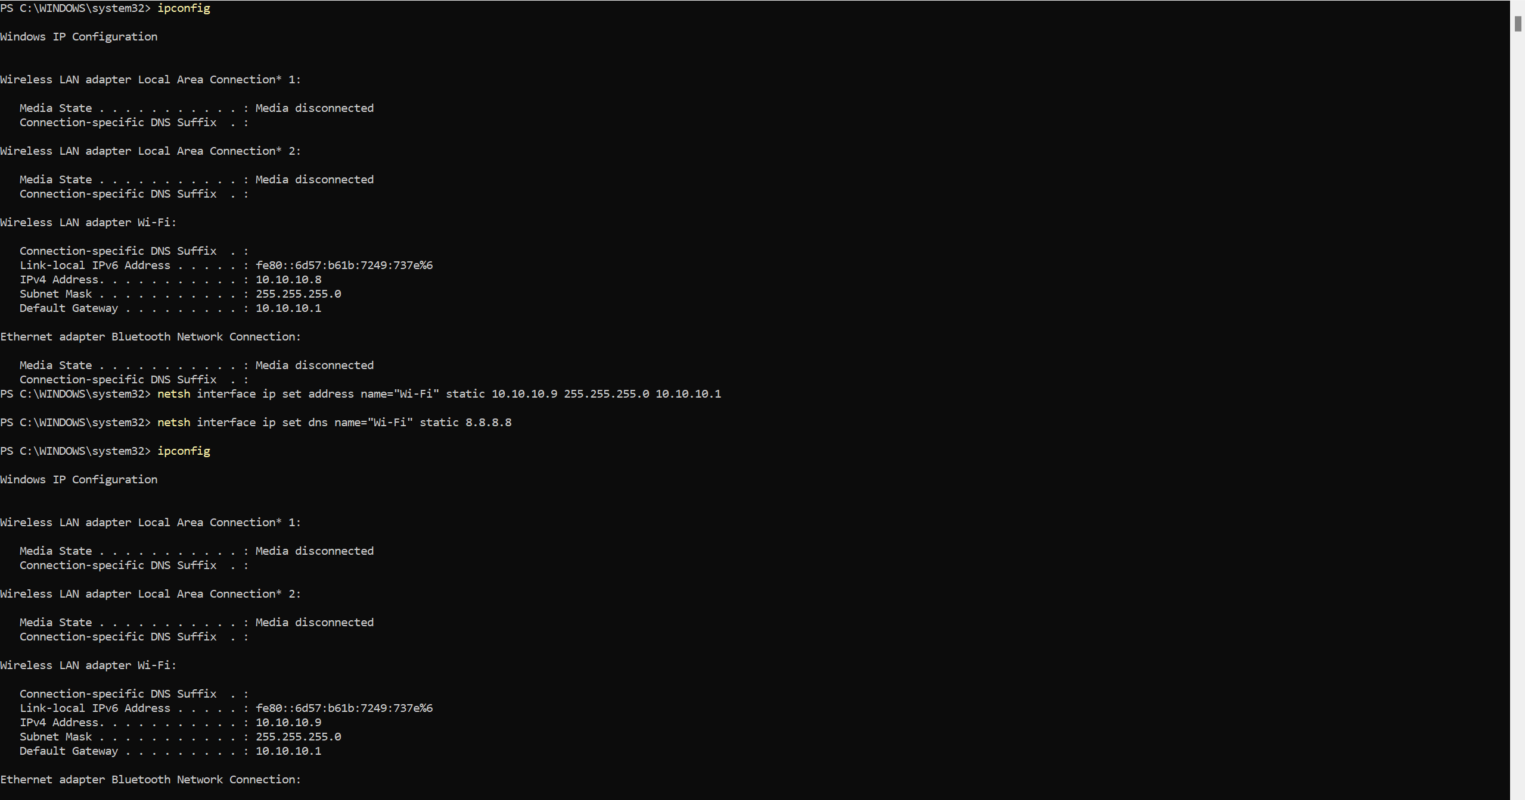

Ping a remote server and understand what packets, packet loss are.

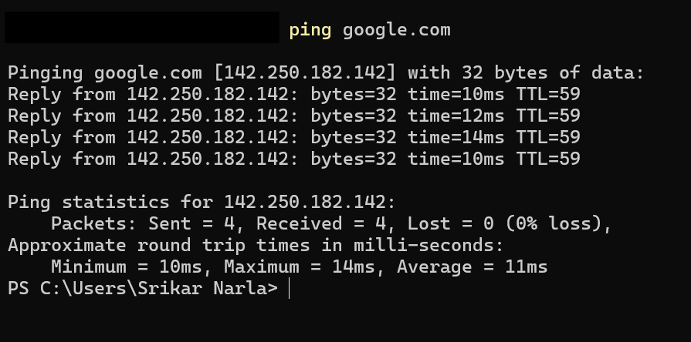

Packet are the small units of data that is transmitted over a network.

Each packet has a header and the content body

Packet loss occurs when a packet fails to reach the destination due to various reasons

Minimum round-trip time: The shortest time it took for a packet to travel to the target and back.

Maximum round-trip time: The longest time it took for a packet to travel to the target and back.

Average round-trip time: The average time it took for packets to travel to the target and back.

Perform traceroute to a server

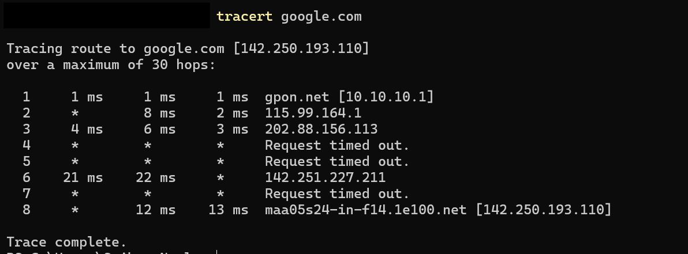

Hops: Each hop represents a router or gateway the packet passes through on its way to the destination. The first hop is usually the home router(default gateway)